IT24100889

Henarangoda M.P

Lab Sheet 09

**Exercise**

1. Assume that the time taken to bake a batch of cookies is normally distributed with mean 45 minutes and standard deviation 2 minutes.

i. Generate a random sample of size 25 for the baking time.

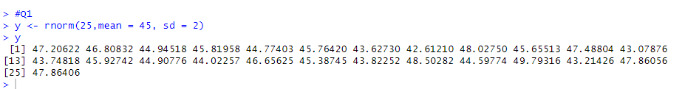

ii. Test whether the average baking time is less than 46 minutes at a 5% level of significance

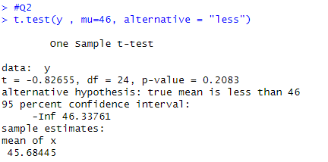

Conclusion: Since the p-value (0.02442) is less than 0.05, we reject H0 at the 5% level

of significance. Therefore, we can conclude that the true mean baking time of cookies

is less than 46 minutes.